Project Brief: London Borough Expansion Analysis (HM Land Registry Price Paid Data)

Background and decision
A London lettings and sales agency (a fictional client, used for this portfolio project) plans to open two new branches in 2027 and needs to know which boroughs to choose. Leadership wants a ranked shortlist backed by data, not a description of the housing market.
The agency earns sales commission and letting fees. A good borough therefore has active sales, rising prices, a strong rental yield, and local buyers who can still afford to transact. The analysis uses public data only, led by HM Land Registry Price Paid Data.
The reader is the Head of Expansion, who is non-technical and will decide from a two-page memo and a one-page dashboard.

Objective and success criteria
The objective is a ranked shortlist of London boroughs, with a recommendation of two to open in and three to avoid, each backed by numbers a non-technical reader can check.
The work is successful when:
- Every borough in scope is scored on the same five metrics, using the definitions in this brief.
- Every figure in the memo traces back to a SQL view and a written metric definition.
- The two recommended boroughs stay in the top five when the weights change, or the memo says plainly that they do not.
- The pipeline re-runs from the raw files with one script and passes every data quality check.
- The Head of Expansion can find the answer on the dashboard in under a minute.

Key questions
The analysis must answer five questions, in this order:
- Where have prices risen over the past five years, and is that growth steady or volatile?
- Where is sales volume recovering or falling? Volume drives sales commission.
- Where does a property earn the most in rent relative to its price (gross rental yield)?
- Where can people who live and work locally still afford to buy?
- Which boroughs rank highest overall, and does the ranking hold when the weights change?

Scope
Version 1 covers the 32 London boroughs over 11 full calendar years, 2015 to 2025.
Item | In scope | Out of scope
Geography | The 32 London boroughs | City of London (too few residential sales to rank; shown but flagged); rest of England and Wales
Period | January 2015 to December 2025 | 2026 year to date (incomplete because of registration lag)
Transactions | Price Paid category A (standard) sales; property types detached, semi-detached, terraced and flat | Category B sales; property type "other"; sales below the price floor
Property market | Residential sales and private rents | Commercial property (Price Paid Data does not cover it)
Analysis type | Descriptive and comparative | Price forecasting
Stretch for version 2 | None committed | Price per square metre using EPC floor area; interest rate sensitivity

Metric definitions
Five metrics feed the borough score, plus median price for context. A borough-year needs at least 30 sales to have a median; below that the value is left empty and flagged.
Metric | Definition | Better when | Default weight
Median sale price | Median price of category A sales in a borough and year | Context only | None
5-year price growth | Compound annual growth of median price, 2020 to 2025: (median 2025 ÷ median 2020)^(1/5) − 1 | Higher | 25%
Sales volume trend | Average annual change in number of sales, 2022 to 2025 | Higher | 15%
Price volatility | Standard deviation of annual median-price growth, 2015 to 2025 | Lower | 10%
Gross rental yield | 12 × median monthly rent ÷ median sale price, latest full year | Higher | 30%
Affordability | Median sale price ÷ median annual earnings of full-time employees living in the borough, latest year | Lower | 20%
Each metric is rescaled to 0 to 100 across the boroughs, inverted where lower is better, then combined into a weighted score:
S_b = \sum_{m} w_m \, N_{b,m}, \qquad \sum_{m} w_m = 1
Here N is the rescaled value of metric m for borough b and w is its weight. The weights are starting points, to be confirmed once the sensitivity check shows how much they matter.

Data sources
Four datasets are committed for version 1. Definitions and availability are confirmed during data discovery in week 1 and logged in the data dictionary.
Dataset | Publisher | Grain | Used for | Main caveat
Price Paid Data | HM Land Registry | One row per registered sale | Price, volume, property mix | No floor area or bedrooms; recent months are revised; status D rows are deleted records
ONS Postcode Directory | Office for National Statistics | One row per postcode | Mapping each sale to a borough | Some postcodes are retired or new; the match rate must be reported
Earnings by place of residence | Office for National Statistics | Local authority, annual | Affordability | Sample estimates; use residence-based, not workplace-based, figures
Private rents | ONS or Valuation Office Agency | Local authority | Gross rental yield | Sources differ in definition and start date; one is chosen and the reason logged
EPC register (stretch) | Ministry of Housing, Communities and Local Government | One row per certificate | Price per square metre | Address matching to Price Paid Data is messy; version 2 only

Approach
The work follows a warehouse-style layered model in PostgreSQL, with each layer built by numbered, version-controlled SQL files.
- Raw (raw schema): untouched loads of every source file. Never edited.
- Staging (stg): typed and renamed columns, postcodes standardised, deleted records removed, duplicates dropped, every dropped row counted by reason.
- Core (core): one row per sale, joined to borough through the postcode directory, with a single borough key used everywhere.
- Marts (mart): borough-by-year tables and views for median price, growth, volume, volatility, yield and affordability.
- Scoring: rescale, weight and rank the boroughs, then rerun with alternative weight sets and report how far each borough's rank moves.
Data quality checks run between layers and write their results to a log table, so a failed check stops the build instead of passing silently.

Data quality and risks
Eight automated checks guard the pipeline, and six known risks have a planned response.
Check | Rule | If it fails
Row reconciliation | Raw rows = staging rows + dropped rows, with a reason for every drop | Stop and investigate
Unique transactions | No duplicate transaction IDs in core | Stop; document the dedupe rule
Deleted records | Record status D removed in staging | Log the count
Price range | Price at least £10,000; upper cap set after inspecting the distribution | Log and exclude
Postcode match | At least 99% of in-scope sales matched to a borough | Report the rate and list unmatched postcodes
Minimum sample | At least 30 sales per borough-year | Leave the median empty and flag it
Geography level | ONS files filtered to one geography level before use | Stop; prevents double counting
Weights | Weights sum to 100% | Stop

Risk | Response
Rent and price definitions differ (for example, all dwellings against a mix of property types) | Compare like with like where possible and state the limit in the memo
Recent Price Paid months are incomplete | End the window at December 2025
Earnings are sample estimates, and some boroughs may be missing or unreliable | Show the quality flag and document gaps
Outliers distort averages | Use medians, not means, and log every exclusion
A large borough dominates or a small one is noisy | Enforce the minimum sample and show sales counts beside every median
Scope creep | Freeze version 1 at four datasets; list extras for version 2

Deliverables
Four deliverables go to the client, all built from the same marts so the numbers agree.
- Recommendation memo (PDF, two pages): the two boroughs to open in, three to avoid, the reasons, and the limits of the data.
- Power BI dashboard: a summary page with the ranked shortlist, a borough comparison page, and a methodology page with definitions and weights.
- Reproducible repository: numbered SQL files, Python loading and validation scripts, and a README that explains how to rebuild the project from scratch.
- Documentation: this brief, a data dictionary, and an assumptions and decisions log.

Timeline
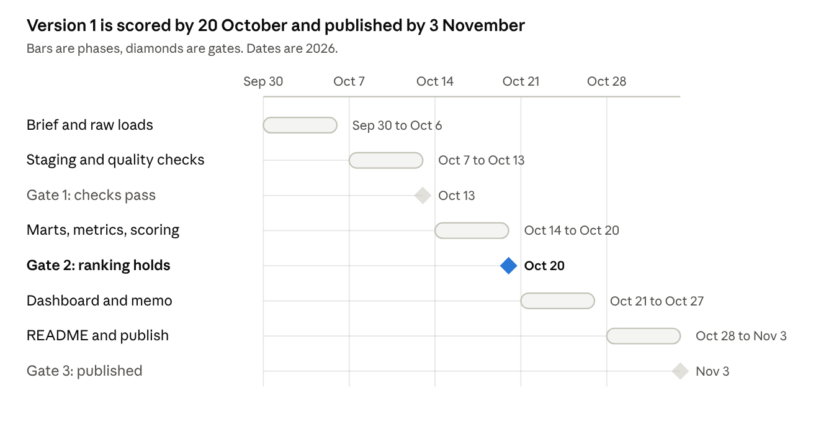
delivery timeline · 5 phases, 3 gates
Gate 1 needs every data quality check to pass. Gate 2 needs the two recommended boroughs to hold their rank when the weights change, or the memo says they do not. Gate 3 is the repository and dashboard published.

Assumptions and open decisions
Each row below moves into the repository's assumptions log once it is confirmed or changed, with the reason and the alternative.
Decision | Current choice | Alternative
Outlier handling | £10,000 price floor; upper cap after inspecting the distribution | Percentile-based trimming
Category B sales | Excluded from headline metrics, shown as a sensitivity | Include all sales
City of London | Shown but not ranked (too few sales) | Rank it with a low-sample flag
Yield basis | All dwellings for both rent and price | Separate flat and house yields
Rent source | Decided in week 1 after comparing definitions and coverage | The other source, used as a cross-check
Weights | 30 / 25 / 20 / 15 / 10 as set in the metric table | Equal weights; client-agreed weights
Window end | December 2025 | Roll forward once 2026 is complete

